- Application Started Successfully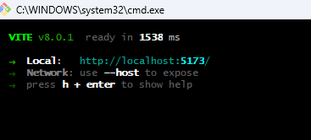
- http://localhost:5173
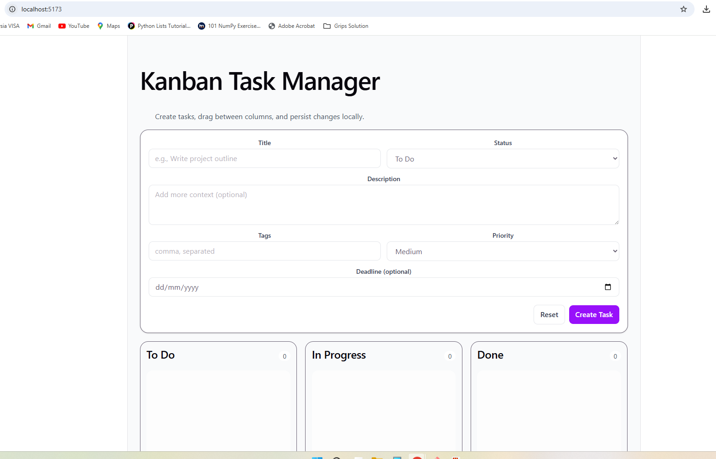
- Curl http://localhost:5173
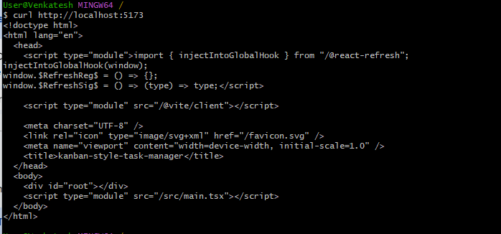

- Docker Image build Succeeded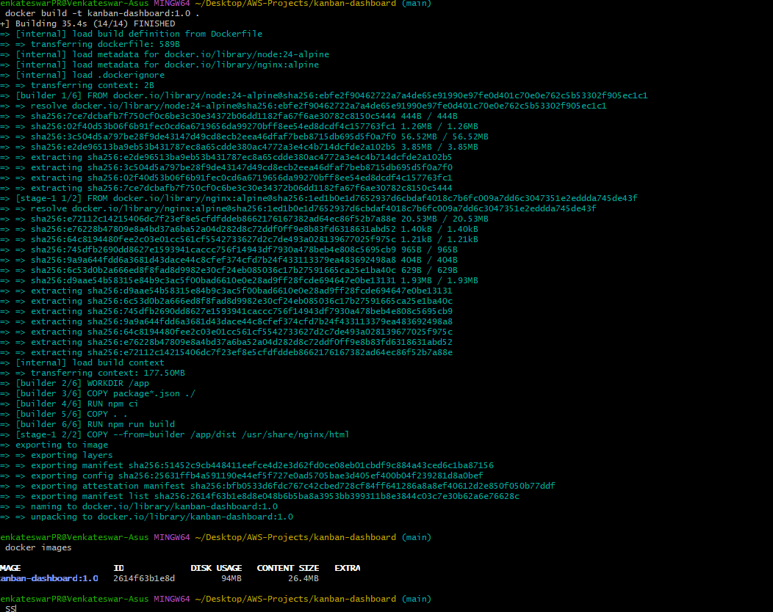
- Container Running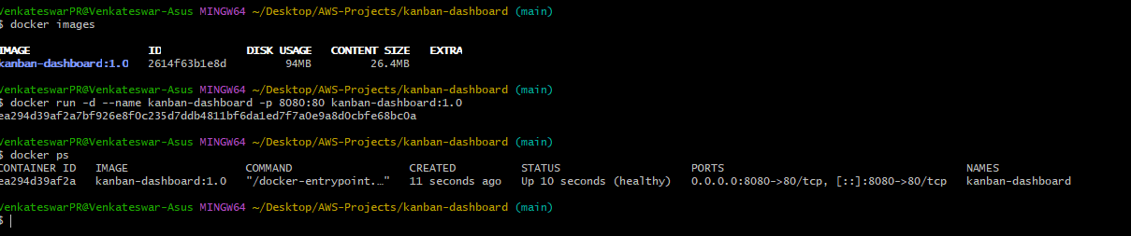
- Docker Application:
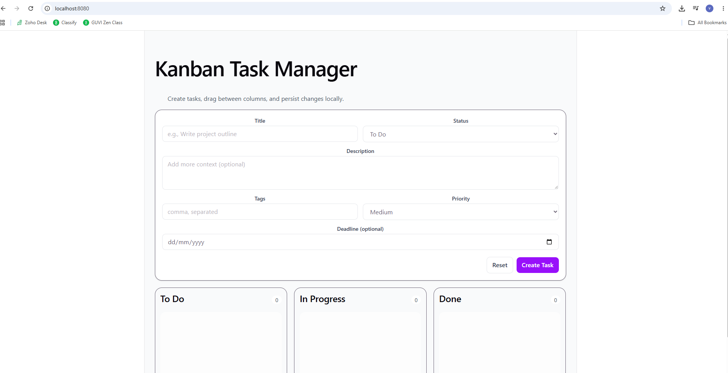
- Curl status of Docker: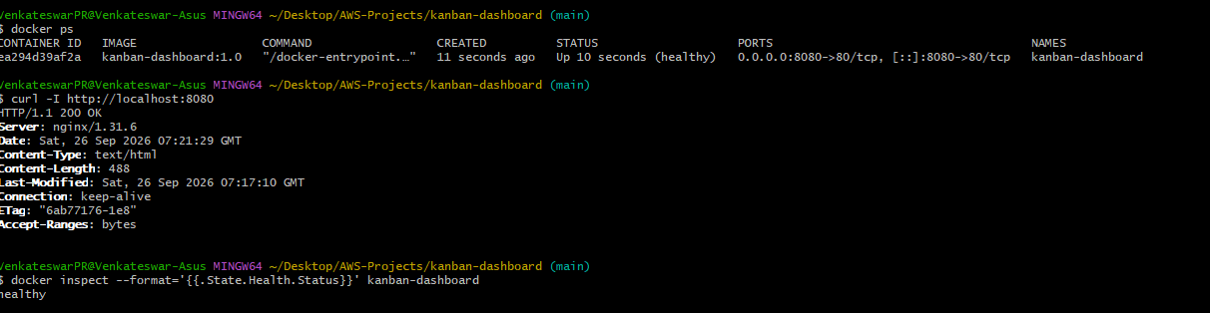
- Docker Logs: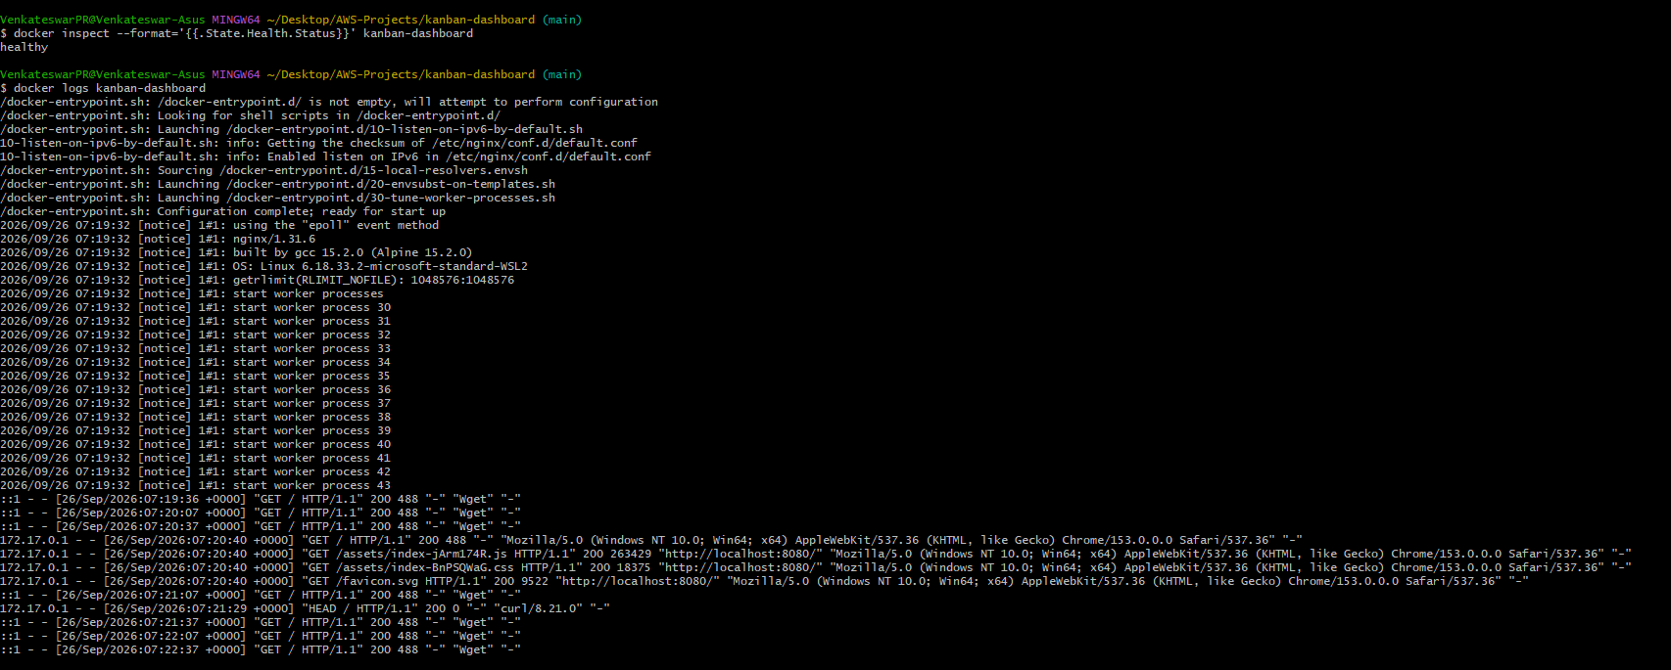
- Docker Security Health and Resource limits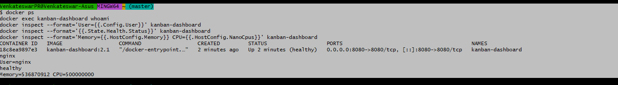
- Docker Repository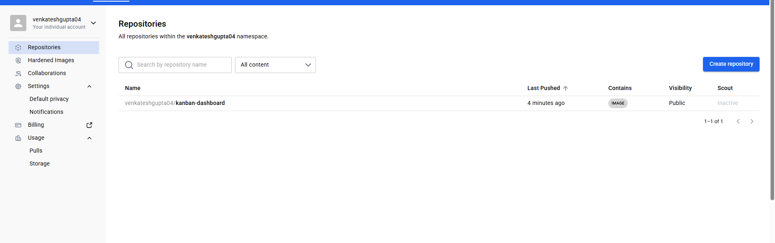
- Created Ubuntu server and installed docker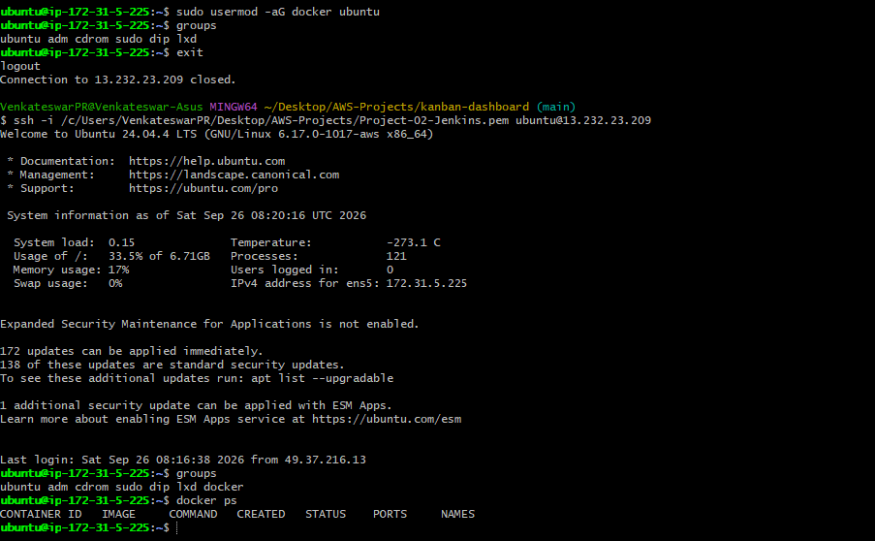
- Pulled images from venkateshgupta04/kanban-dashboard 2.1 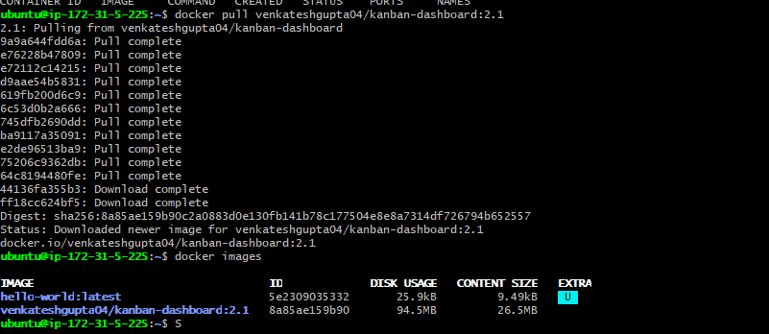
- EC2 container health and test application 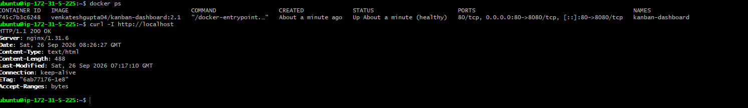
- Testing Application through Public IP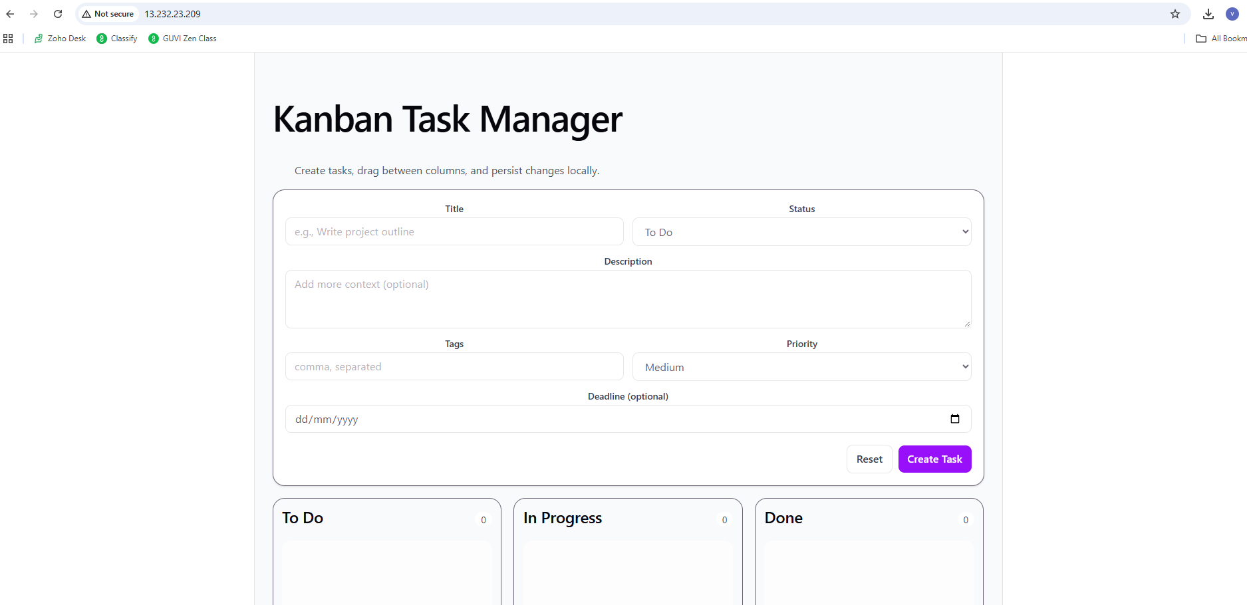
- Jenkins Installation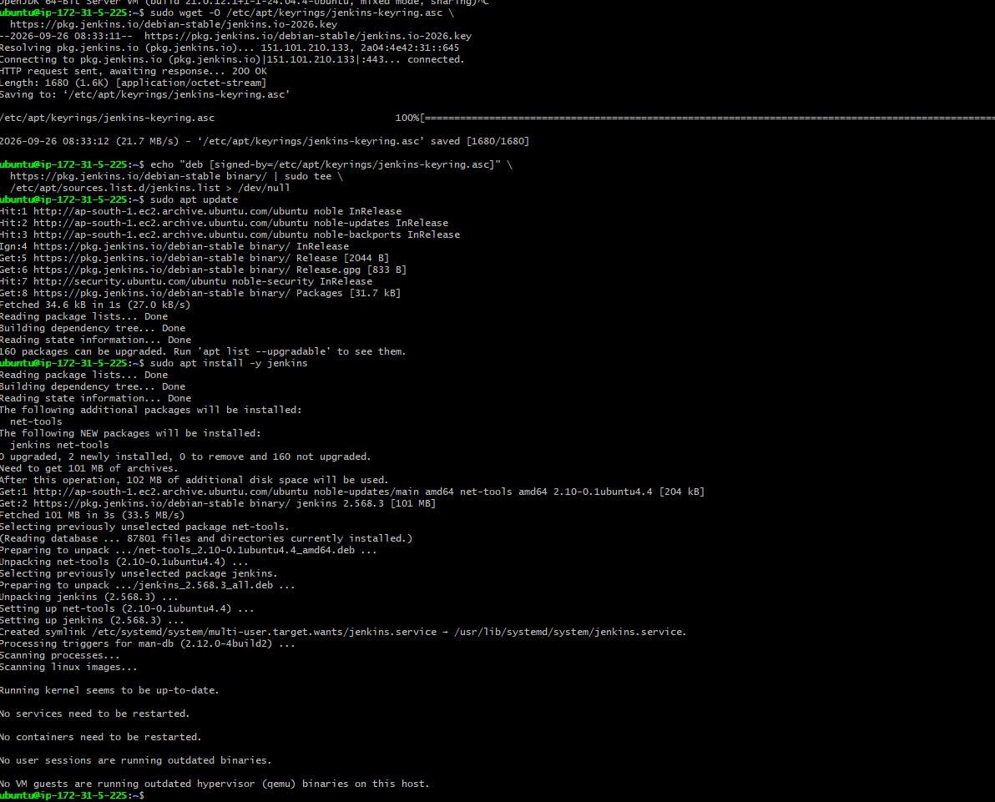
- Jenkins Enabled: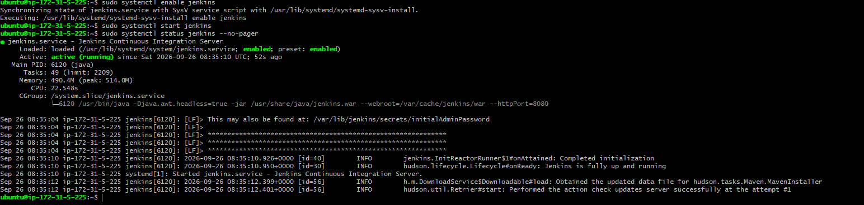
- Package Installation in Jenkins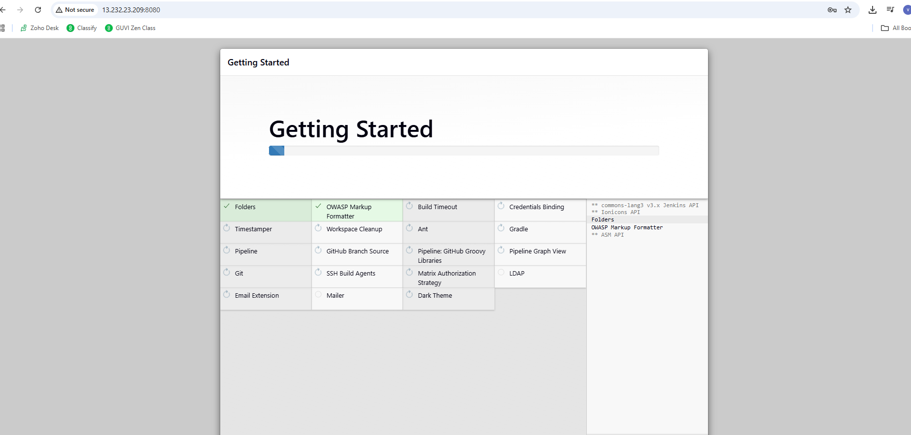
- Jenkins successfully been installed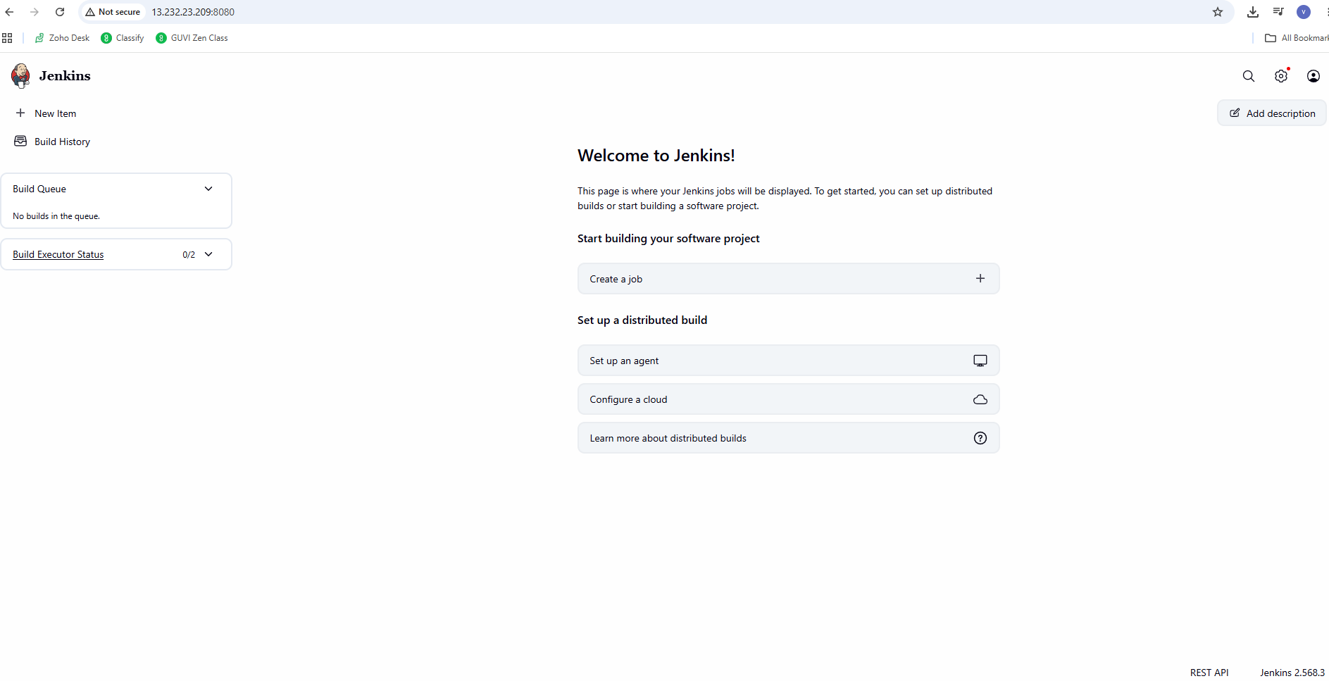
- Docker - Jenkins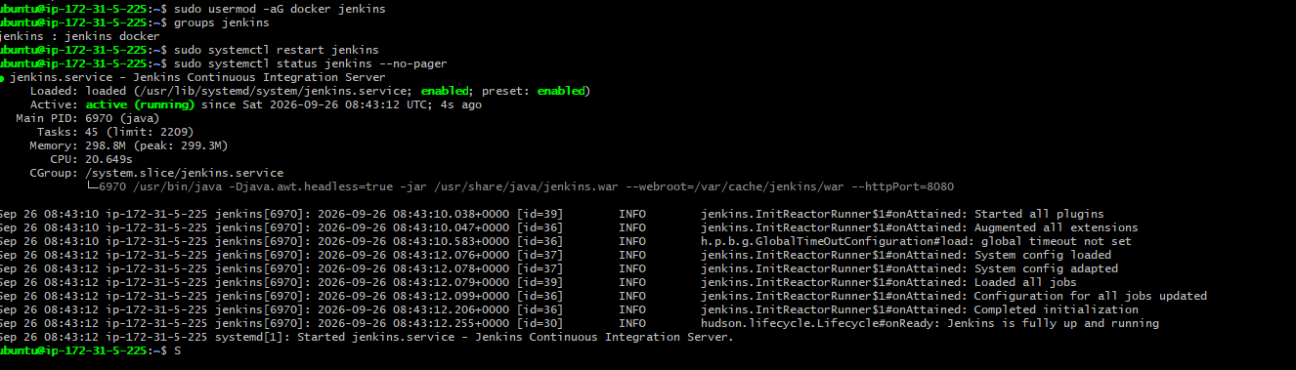
- Pipeline in Jenkins has been created for the project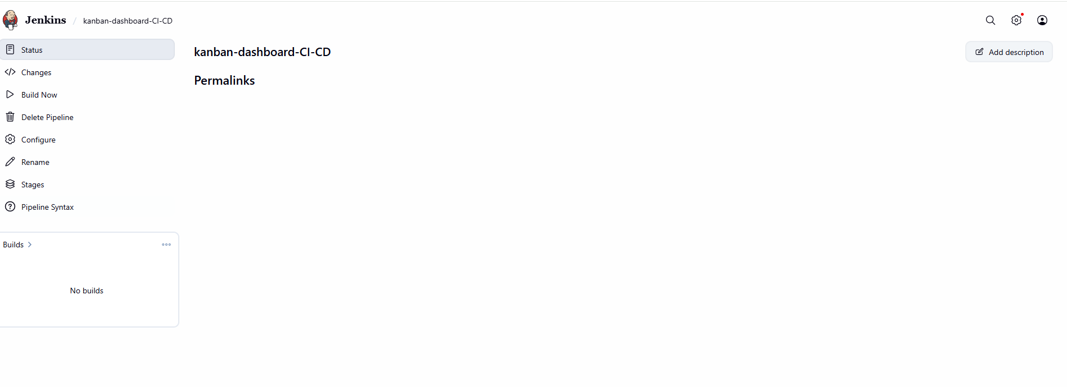
- Added Jenkinsfile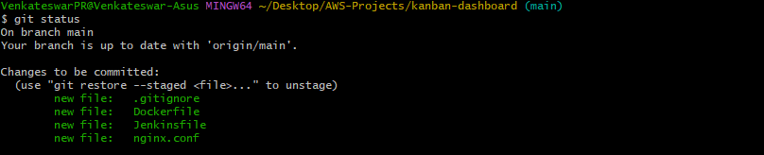
- Pushed Jenkin File to Github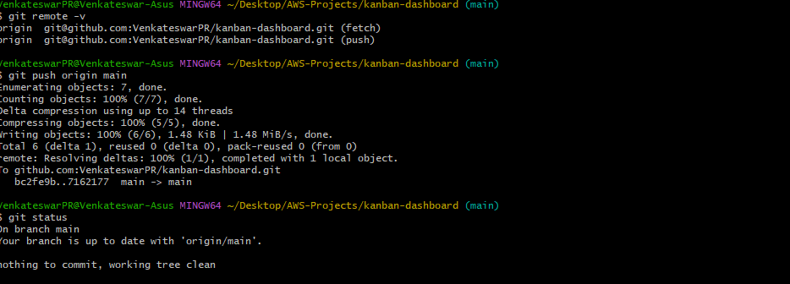
- Jenkins build Successfull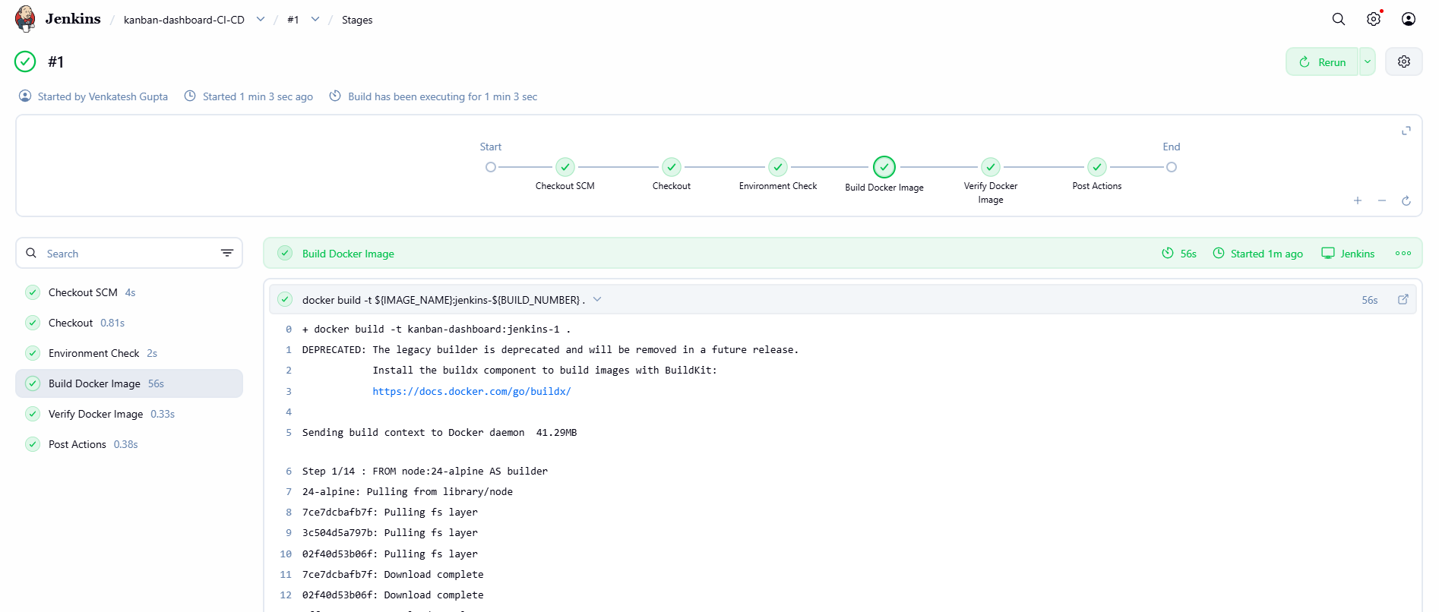
- PAT created in Docker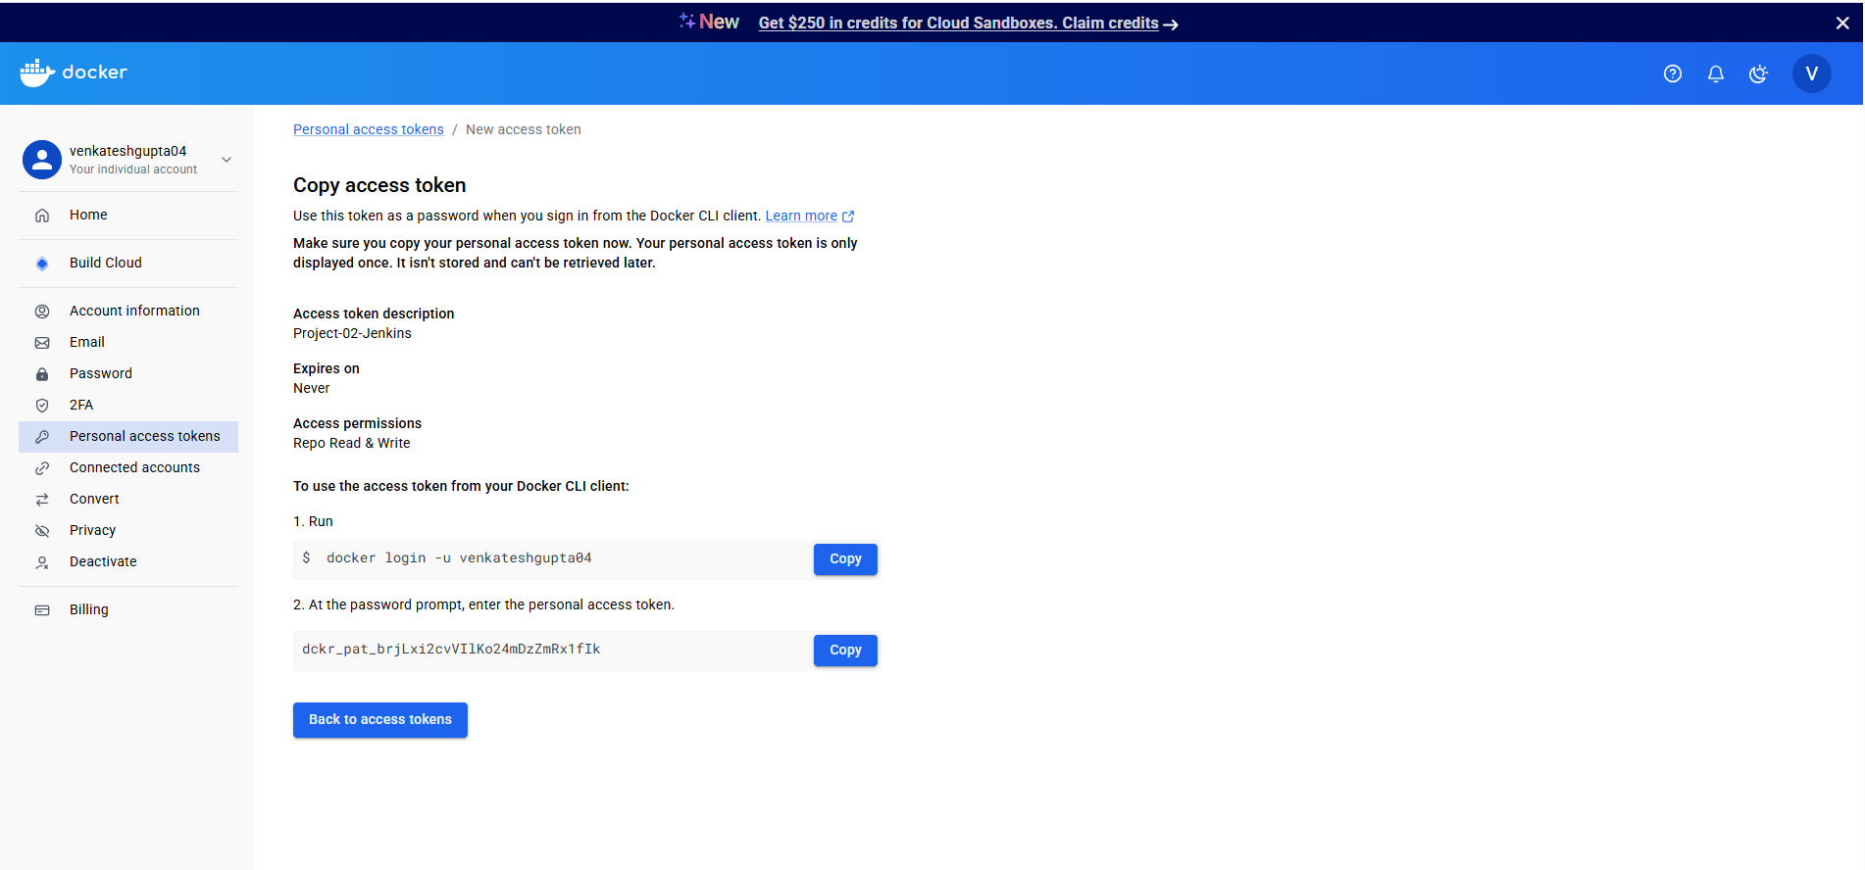
- Docker PAT mapped with Jenkins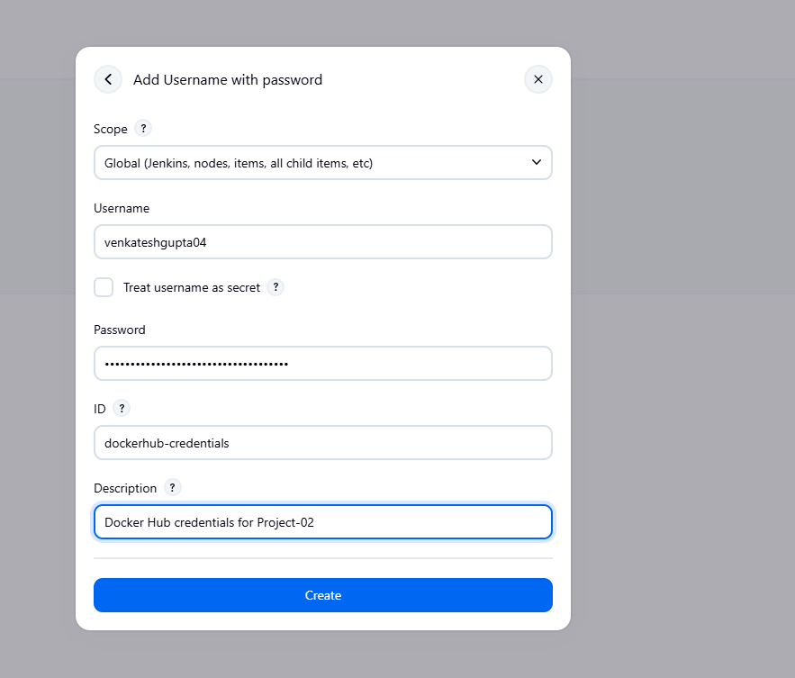
- Changes done in Jenkins File to test Build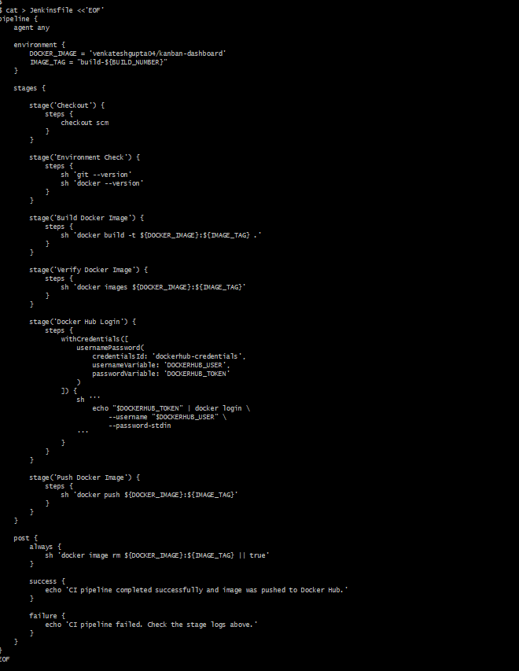
- Jenkins Dockerhub push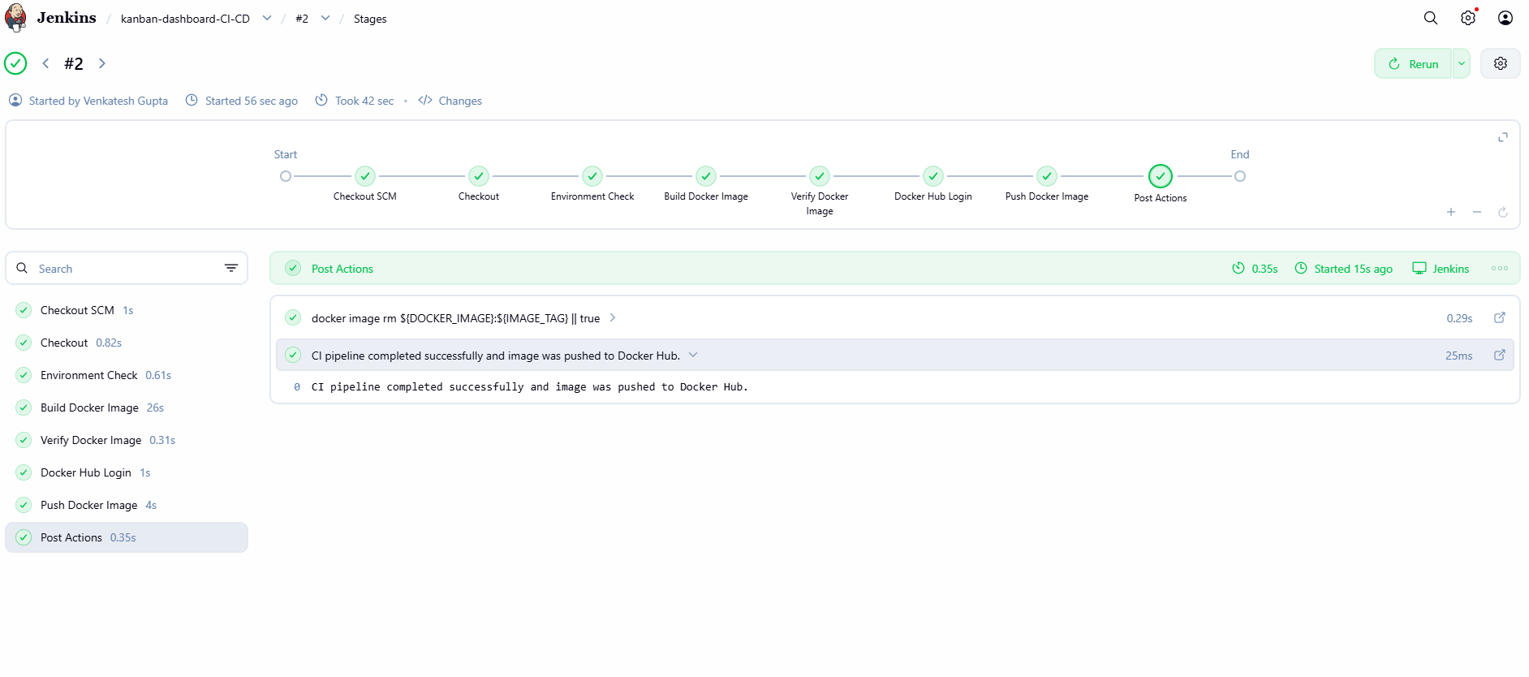
- Changing Port in dockerfile to test rollback: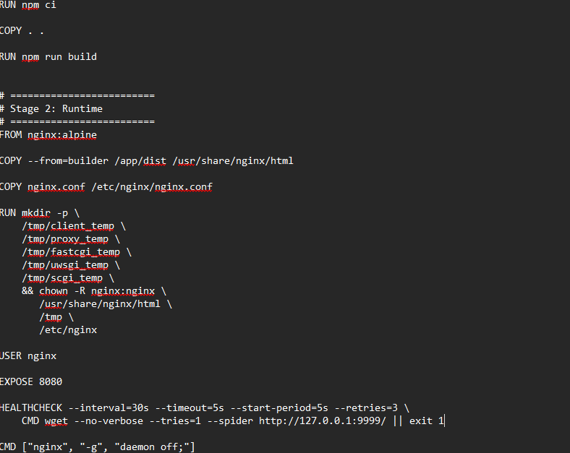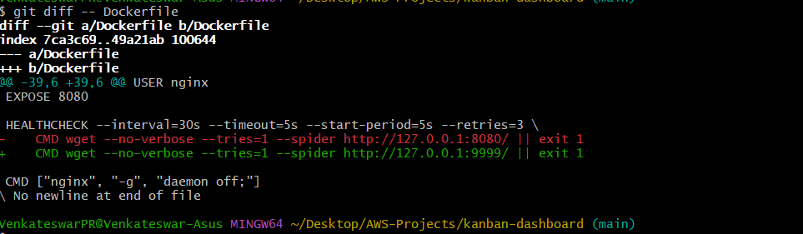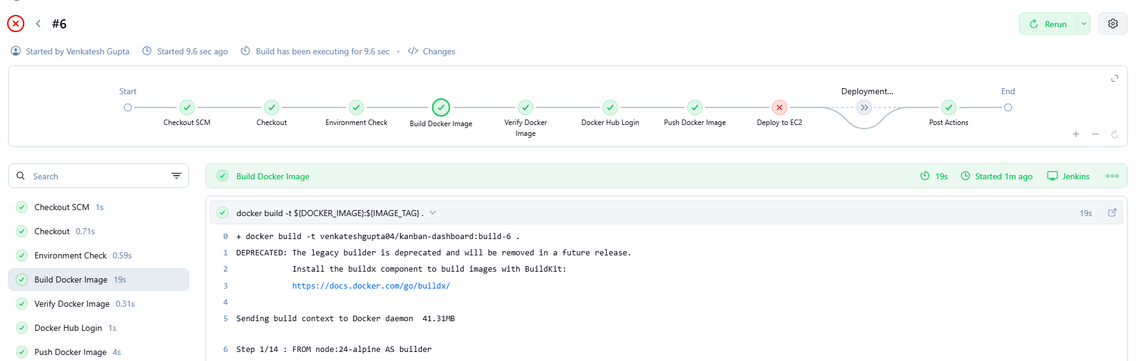
- Fixed code again to check correct build